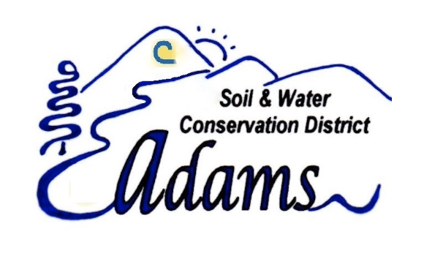
Adams Soil and Water Conservation District (ASWCD) “Go On” Scholarship
Amount: $1000
Number of Scholarships Awarded: 2
Who is eligible? High school seniors living in Adams County that are planning to earn a degree in natural resources related field or agriculture
How to Apply: Write a letter to the Adams Soil and Water Conservation District Board. In the letter, introduce yourself and explain why the board should invest in your future. You should also include the following information:

- GPA and other evidence of academic achievement
- The name of the institution you will attend
- Why you are interested in agriculture or natural resources
- Any work or volunteer experience you have in agriculture and/or natural resources
- Anticipated cost for your first academic year and how you will pay for it
Send Your Application Letter to:
ASWCD Scholarship, P.O. Box 26 Council, Idaho 83612 or email it to aswcdidaho@gmail.com
Questions? Contact the board at aswcdidaho@gmail.com
Due Date: Friday, April 2, 2027
How will applicants be judged? Based on qualification and need

